**The Gray Area Project**

**Expanding Our**

**Understanding of Good vs. Evil**

**Criteria for Success:**

* One long story or three short stories, fiction or nonfiction
* Incorporates a main theme of:
  + good→ evil
  + evil→ good
  + neutral → good or bad
* No word or page limit, but your story should include:
  + Introduce your characters
  + A problem or dilemma
  + A turning point or climax
  + A resolution or conclusion
* A reflection explaining how your story connects to A.I.
  + Are people only evil? Only good?
  + How might a machine react to your characters?

**Discussion Questions:**

1. If a machine was coded using the Jedi Code what might happen? What might happen to people who are ignorant? How could this code be a bad thing?
2. If a machine was coded using the Sith Code what might happen? When is it a good thing to “break free of your chains?” How could this code be a good thing?
3. If a machine was coded using the Gray Jedi Code what might happen?
4. Would you want a machine to have your original ethical code? Why or why not?
5. If you could create a new ethical code for a machine what would it look like? Would it look similar to the Sith, Gray Jedi, or Jedi code?

**Sith Code**

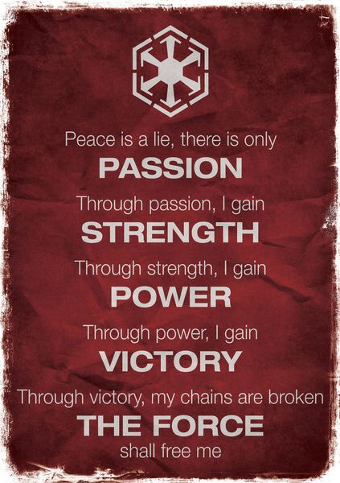

**Jedi Code**

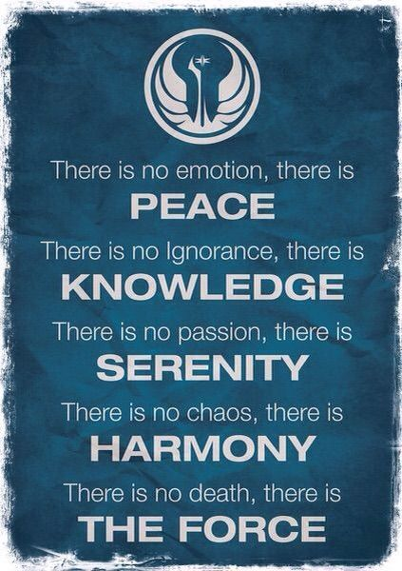

**Gray Jedi Code**

